**Dealing with REST Responses:**

Remove the getUser() method in the DataService.ts

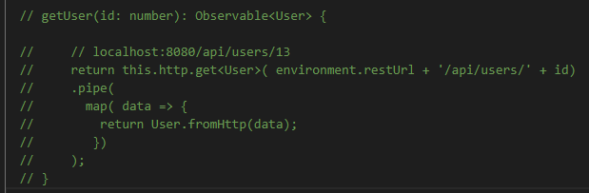

Remove the initial user in the ngOnInit() in the Calendar.component.ts class

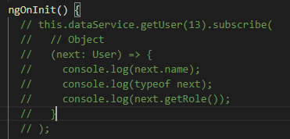

Test rooms and users to make sure they work

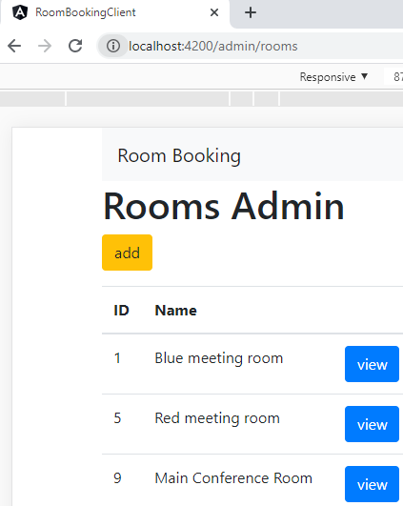

No console Errors

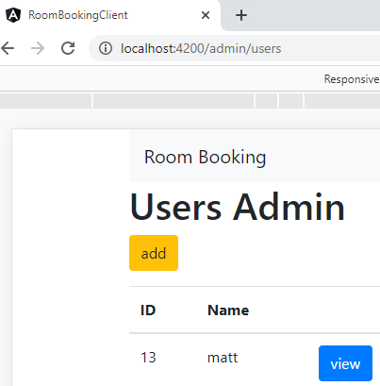

No Errors after saving several times

Now, let us simulate a Network Delay

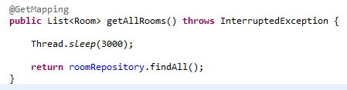

Restart the application to enforce the new code change

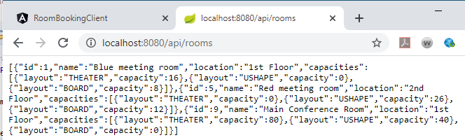

A time delay occurs now in the app

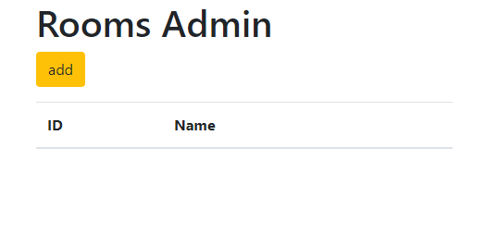

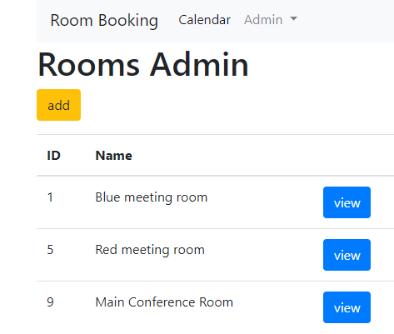

Let us add a message indicating a delay is occurring: Add loadingData

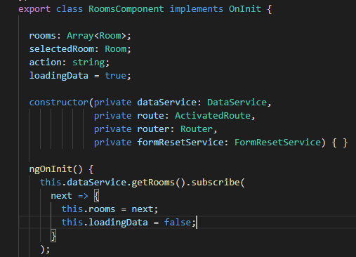

Add the html component

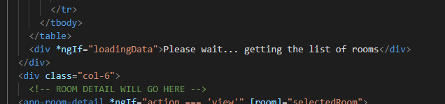

Test this!

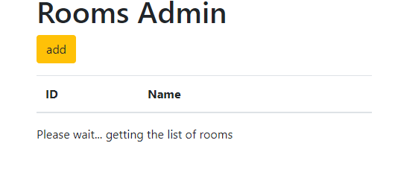

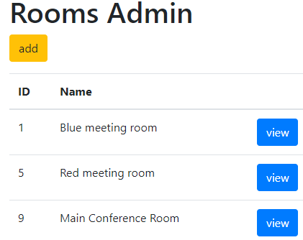

This works!!